Bat Roost Analysis

TBC

07/02/2020

# Summary

A total count of **130 Natterer’s bat** were found at a **House** roost on **2015-04-18** in **Somerset, South West, England**.

# Section 1: All data

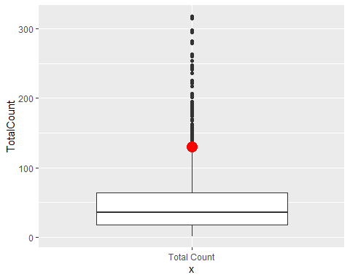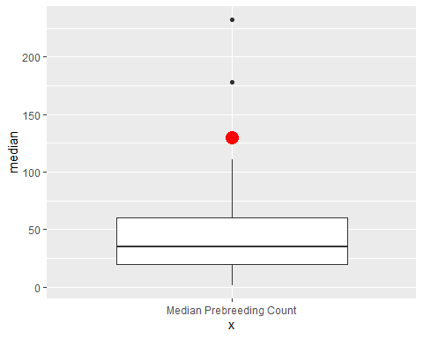

### Figure 1: Need to fix so the boxplots are side by side in one panel.

A boxplot of where your Total Count sits in relation to all the roost counts in the database. The lower line of the box is the lower quartile value and the top line of the box is the upper quartile. The median is the horizobntal black line in the box. The black dots are outliers and the red dot is your roost count of 130 On the right is a subset of the roost data contained in the database. If your roost count was recorded in the months of January and June OR you selected ‘No’ in the column asking if you think babies are flying then this will be all the prebreeding data (Jan - Jun or where answer to this question was negative.) If you answered Yes or your data was recorded July - August, you will see a subset of post breeding data. Your data is the red dot.

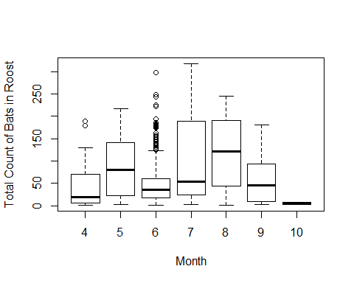

### Figure 2:

A boxplot showing total count of bats in roosts per month across all years.

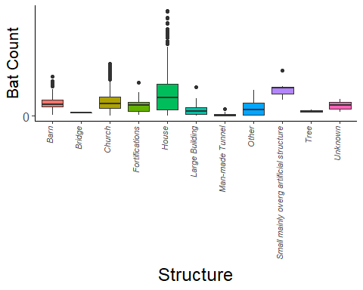

### Figure 3:

Boxplots of total bat count in roosts split by structure type of the roost for all roost counts in database.

# Percentiles Analysis

This analysis looks at the relative size of the bat roost you recorded. We take your total count of bats at the roost recorded and compare this to values in our reference database. We tell you what percentile your data falls at, and therefore what the relative activity level is.

Roosts in the database are ranked based on their percentile score into a **low, low/moderate, moderate, moderate/high, high** and **exceptional** number of bats in a roost.

*All data **Your roost is the** 94 th percentile **when compared to the** 1384 **bat roosts in the dataset.** This means your roost is ranked as a **high** number of bats.

**Breeding subset** This compares your data to a subet of the Ecobat roost data based on the time of year your count was recorded and so whether your roost was recorded pre- or post- young bats flying. If your roost count was recorded in **January - June** OR you selected **no** in the proforma column Do you think young are flying? then your data is compared to our prebreeding data (January to June). If your recording was from **July - December** OR you selected **yes** in the proforma column “do you think young are flying” then your data is compared to our postbreeding data (July - December). If you answered **unsure** in the column “do you think young are flying” then Ecobat will select the subset based on the month of recording.

Your roost is the **96th percentile** when compared to the **99** bat roosts in the dataset. This means your roost is ranked as a **exceptional** number of bats.

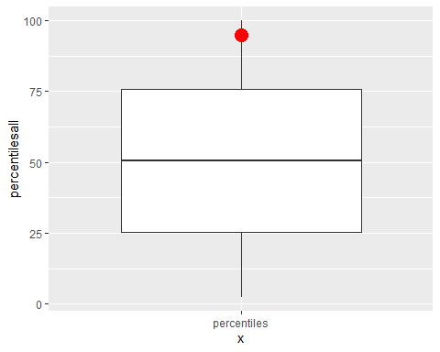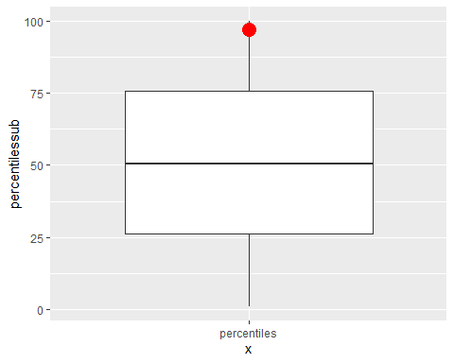

**Figure 4:** A boxplot showing where your data lies in relation to all other roost data (left) and a boxplot showing where your data lies in relation to a subset of data based on month of recording and whether you think young bats are flying (right). Values are the percentile values.

# Section 2: A subset

# Have not edited beyond this point since 12/02/2020, this needs to be incorporated into the subset including pre and post breeding but leaving for now - fear that if data is narrowed much more there won’t be much to compare!

The following section will now use a subset of roosts held in the database, specified by you.

WILL HAVE SPECIFIC THINGS FROM PROFORMA THAT GET SUBSETTED OUT E.G IF THEIR STRUCTURE IS A HOUSE, IT WILL LOOK AT ALL WITH HOUSE ETC. USERS MAY BE ABLE TO SELECT WHICH COLUMNS THEY FILTER FOR E.G. WHETHER TO ALSO FILTER FOR REGION, ETC